Task 14:

The tasks are as follows:
Configure pc4 as Nagios/Zabbix server
Using Nagios/Zabbix server, monitor other PC’
monitor the load, CPU, Memory utilization of OS, web server, DNS Server and other PC’s

1. In pc4
sudo apt-get update
sudo apt-get install -y autoconf gcc libc6 make wget unzip apache2 php libapache2-mod- php7.2 libgd-dev
2.Downloading the Source
cd /tmp
wget -O nagioscore.tar.gz https://github.com/NagiosEnterprises/nagioscore/archive/nagios-4.4.5.tar.gz
tar xzf nagioscore.tar.gz
3.Compile
cd /tmp/nagioscore-nagios-4.4.5/
sudo ./configure --with-httpd-conf=/etc/apache2/sites-enabled
sudo make all
4.Create User and Group
This creates the nagios user and group. The www-data user is also added to the nagios group.
sudo make install-groups-users
sudo usermod -a -G nagios www-data
5.Install Binaries
This step installs the binary files, CGIs, and HTML files.
sudo make install
6.Install Service / Daemon
This installs the service or daemon files and also configures them to start on boot.
sudo make install-daemoninit

7.Install Command Mode
This installs and configures the external command file.
sudo make install-commandmode

8.Install Configuration Files
This installs the *SAMPLE* configuration files. These are required as Nagios needs some configuration files to allow it to start.
sudo make install-config

9.Install Apache Config Files

This installs the Apache web server configuration files and configures Apache settings.
sudo make install-webconf
sudo a2enmod rewrite
sudo a2enmod cgi
10.Configure Firewall
You need to allow port 80 inbound traffic on the local firewall so you can reach the Nagios Core web interface.
sudo ufw allow Apache
sudo ufw reload
11.Create nagiosadmin User Account
You'll need to create an Apache user account to be able to log into Nagios.
The following command will create a user account called nagiosadmin and you will be prompted to provide a password for the account.
sudo htpasswd -c /usr/local/nagios/etc/htpasswd.users nagiosadmin
When adding additional users in the future, you need to remove -c from the above command otherwise it will replace the existing nagiosadmin user (and any other users you may have added).

12. Installing The Nagios Plugins
sudo apt-get install -y autoconf gcc libc6 libmcrypt-dev make libssl-dev wget bc gawk dc build-essential snmp libnet-snmp-perl gettext

13.Downloading The Source
cd /tmp
wget --no-check-certificate -O nagios-plugins.tar.gz https://github.com/nagios-plugins/nagios-plugins/archive/release-2.2.1.tar.gz
tar zxf nagios-plugins.tar.gz
14.Compile + Install
cd /tmp/nagios-plugins-release-2.2.1/
sudo ./tools/setup
sudo ./configure
sudo make
sudo make install
15. apt-get install libapche2-mpd-php
Run below commands
a2dismod mpm_event
a2enmod mpm_prefork
a2enmode cgl
a2enmode php7.0
systemctl restart apache2
systemctl start nagios
16.Test Plugins
Point your web browser to the ip address or FQDN of your Nagios Core server, for example:
http://172.20.10.14/nagios

17.In pc1&pc2 install nagios plugins
yum install -y gcc glibc glibc-common make gettext automake autoconf wget openssl-devel net-snmp net-snmp-utils epel-release
yum install -y perl-Net-SNMP
yum install -y nrpe
18.Downloading the Source
cd /tmp
wget --no-check-certificate -O nagios-plugins.tar.gz https://github.com/nagios-plugins/nagios-plugins/archive/release-2.2.1.tar.gz
tar zxf nagios-plugins.tar.gz
19.Compile + Install
cd /tmp/nagios-plugins-release-2.2.1/
./tools/setup
./configure
make
make install
20. sytemctl start nrpe
systemctl enable nrpe
firewall-cmd --permanent --add-port=5666/tcp
firewall-cmd --reload
21.In pc1&pc2
vim /etc/nagios/nrpe.cfg add nagios server ip as below.
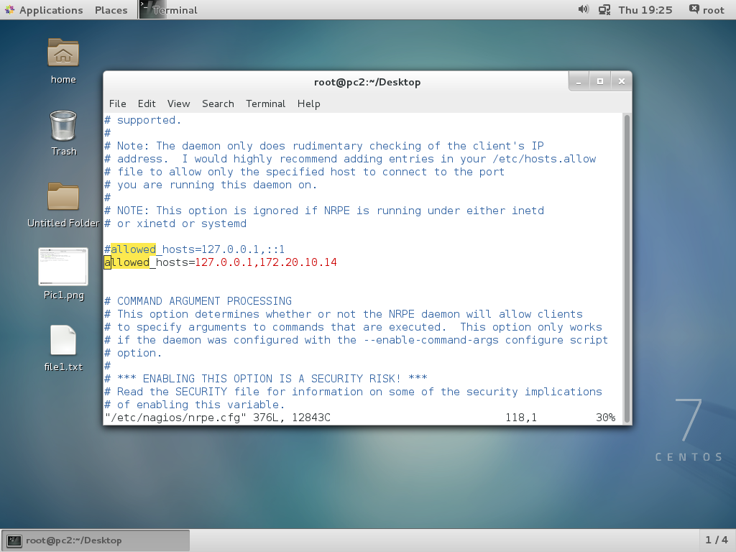
22. pc1 and pc2 add tp nagios server.
Vim /usr/local/nagios/etc/nagios.cfg
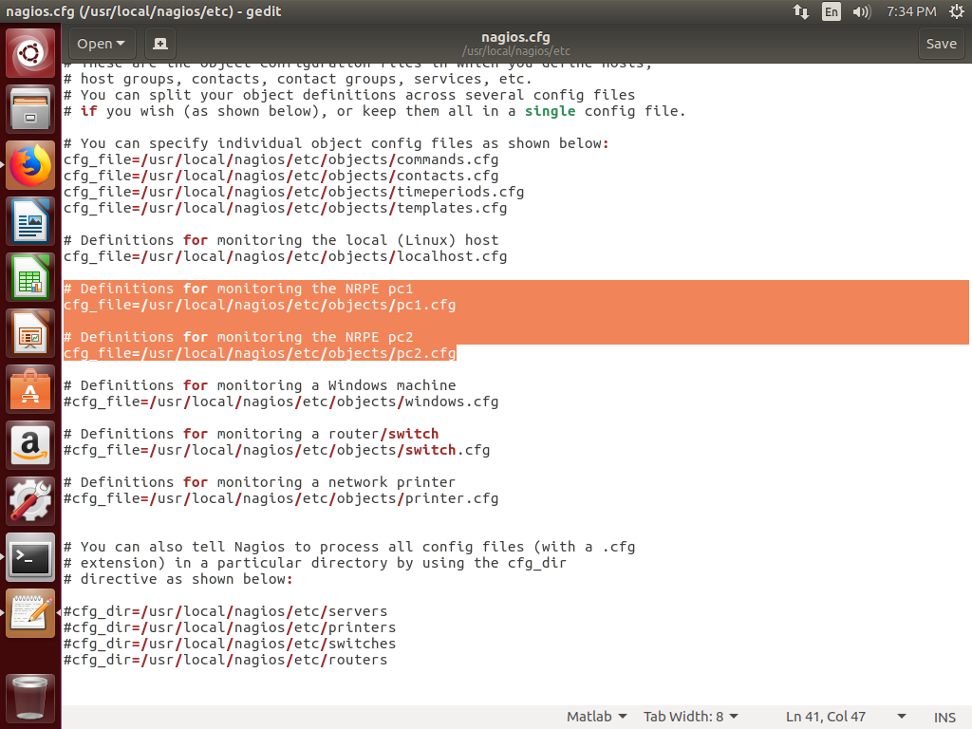
23. vim /usr/local/nagios/etc/objects/pc1.cfg
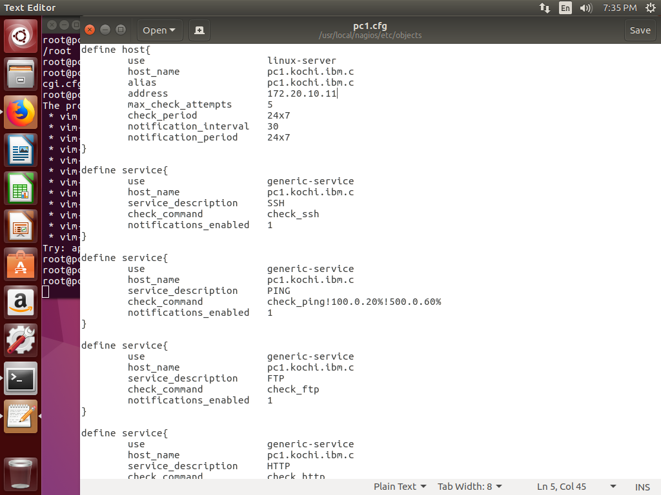
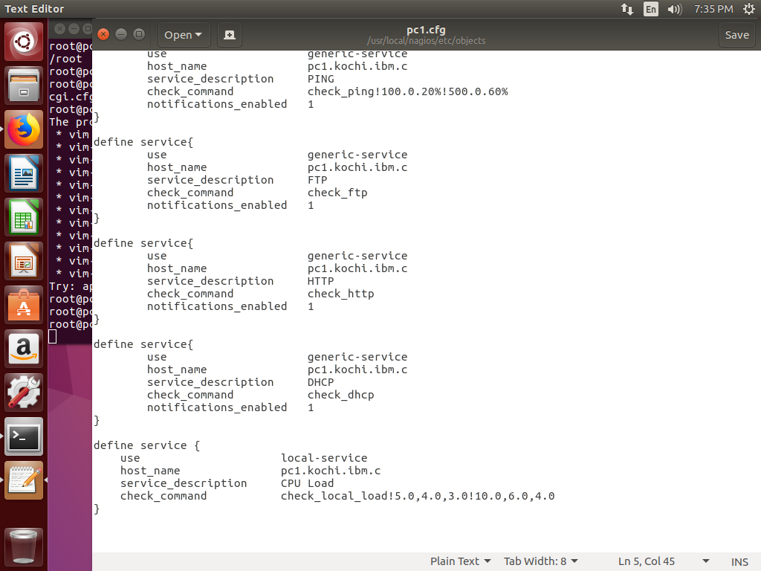
24. vim /usr/local/nagios/etc/objects/pc2.cfg
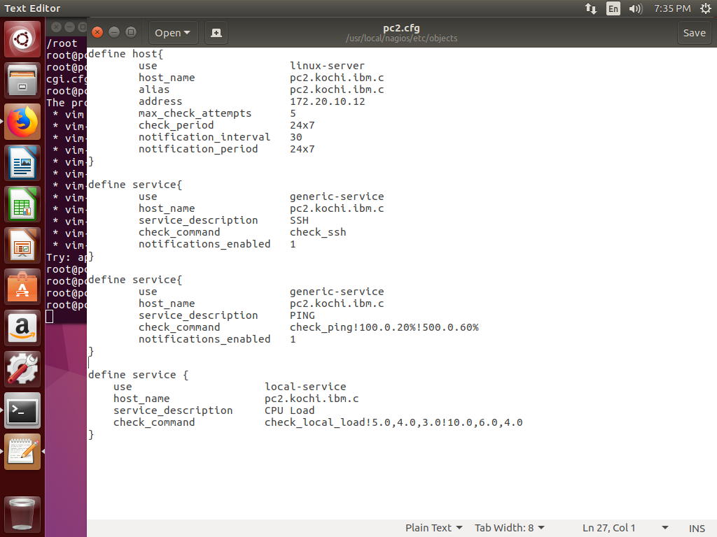
25. Able to login to nagios server web interface, shots given below.
